Contents
1. Introduction to the System 3
1.1 System Overview 3
1.2 Stakeholders 3
1.3 Key Assumptions 3
2. Architectural Design & Justification 4
2.1 Selected Architectural Styles/Patterns 4
2.2 Why These Patterns Are Suitable 4
2.3 How They Support Requirements 4
2.4 How They Complement Each Other 5
3. Non-Functional Requirements (NFRs) 5
3.1 NFR Table 5
3.2 Architecture Mapping Summary 6
4. Conceptual View (Block Diagram) 6
4.1 Purpose 7
4.2 System Structure 7
4.2.1 Presentation Layer (User Interface Subsystem) 7
4.2.2 Application / Services Layer (Business Logic Coordination) 8
4.2.3 Domain Layer (Business Entities) 8
4.2.4 Data / Infrastructure Layer (Repository Subsystem) 9
4.2.5 Storage Layer (Persistence Mechanism) 9
4.3 Mapping to Other Architectural Views 10
5. Process View (Dynamic Behavior) 10
5.1 Selected Scenario / Use Case 10
5.2 Activity Diagram 11
5.3 Sequence Diagram 13
6. Development View (Component Diagram) 15
6.1 Explanation 16
6.2 Component Overview 16
6.3 Interface Definitions 17
6.4 Dependency Structure 17
7. Physical View (Deployment Diagram) 17
7.1 Purpose 18
7.2 Deployment Nodes 18
7.2.2 Application Server (Java Runtime / JVM) 19
7.2.3 Database Server 20
7.3 Communication Paths 21
7.4 Architecture Support for Deployment 21
7.5 Deployment Evolution Roadmap 22
Phase 1: Current — Single-Node Deployment (Demonstration) 22
Phase 2: Enhanced — File Persistence (Short-Term) 22
Phase 3: Production — Client-Server with Database (Future) 22
7.6 Mapping to Development View 23
8. Bonus — Reference Architecture Mapping 24
8.1 Mapping to 4+1 Architectural View Model 24
8.2 Mapping to IEEE 1471 / ISO 42010 24
8.3 Architecture Trade-offs 25
8.4 Transaction Processing System Reference Architecture 25
9. Conclusion 27
Appendix A — Assumptions & Glossary 27
A.1 System Assumptions 27
A.1.1 Deployment Environment 27
A.1.2 Authentication & Authorization 28
A.1.3 Concurrency 28
A.1.4 Data Persistence 28
A.1.5 Scope Limitations 28
A.1.6 Architecture Focus 29

1. Introduction to the System

1.1 System Overview
System name: Hospital Management System
Brief system purpose:
A management system that supports core hospital operations such as managing patient information, booking appointments, coordinating care workflows, and tracking operational events. The system is implemented as a Java application using layered architecture and the Repository pattern to ensure maintainable growth and clear separation between UI, business workflows, and data access.

1.2 Stakeholders
Stakeholder | Role in System
Patients | Receive care, appointments tracked in system
Doctors | Provide care, schedules managed by system
Nurses / Lab Staff | Support care delivery, access patient data
Receptionists / Admin Staff | Manage bookings, patient registration
Hospital Management | Oversee operations, generate reports

1.3 Key Assumptions
- The current system runs as a single-user CLI application executed locally.
- Persistence is modeled as in-memory collections for demonstration; the architecture supports replacing it with a database without changing business workflows.
- Access control is out of scope for the current deliverable; basic validation is performed at the Application/Service layer.
- The system demonstrates architectural patterns (Layered + Repository) applied to a healthcare domain.

2. Architectural Design & Justification

2.1 Selected Architectural Styles/Patterns
Style/Pattern | Purpose | Layer
Layered Architecture | Separation of concerns across UI, business logic, and data | Overall structure
Repository Pattern | Abstract data access, enable persistence flexibility | Data layer boundary

2.2 Why These Patterns Are Suitable
Layered Architecture:
The system is a healthcare/hospital management system that naturally separates into:
- User interaction (CLI menus and input/output)
- Use-case workflows (booking appointments, managing patient records, billing)
- Core domain entities (Patient, Doctor, Appointment)
- Persistence/storage
A layered architecture provides a clear separation of concerns and reduces coupling between these responsibilities. Each layer has a single responsibility and depends only on the layer below it.

Repository Pattern:
Repositories are suitable because the system repeatedly queries and updates domain objects (patients, doctors, appointments). A repository abstraction prevents persistence logic from spreading through the UI and service workflow code, and allows the storage mechanism to evolve (in-memory now, database later) without rewriting business logic.

2.3 How They Support Requirements
Functional Support:
- Use cases are implemented in the Application/Service layer as workflows that coordinate validations and operations on domain entities.
- The Presentation layer triggers these workflows and displays results.
- Example: Booking an appointment flows from CLI_UI → AppointmentService → Repositories.

Data Access Support:
- Repositories provide consistent operations such as findById(...), save(...), and availability checks.
- These operations are reused across many workflows (booking, cancellation, rescheduling).

Quality Support:
- Clear boundaries make the system easier to modify, test, and extend with new features.
- Layer isolation allows unit testing of services with mock repositories.

2.4 How They Complement Each Other
Layered architecture defines the overall structure:
Presentation → Application/Services → Domain → Data/Infrastructure
Repository complements this structure by providing the main boundary between business logic and persistence. Application services depend on repository interfaces rather than concrete storage, which improves:
- Maintainability: Change storage without touching business logic
- Testability: Use mock/in-memory repositories for unit testing
- Flexibility: Switch from in-memory to database without code changes

3. Non-Functional Requirements (NFRs)

3.1 NFR Table
Category | Requirement (Short) | Architecture Support | Trade-off / Risk
Performance | ~2s response (1s retrieval) for up to 100 users | Repository optimizes data access; layered design handles flow & concurrency | Caching adds complexity; in-memory won’t scale
Security | Validate inputs; restrict access via services only | Strict layering + repository prevents direct data access | No authentication yet
Availability | 24/7 operation with data integrity | Layer isolation + repository supports safe data operations | In-memory = data loss on restart
Maintainability | Change business logic without affecting UI/storage | Clear separation of layers; repository isolates persistence | Requires strict adherence to architecture
Scalability | Support up to ~100k patients without major changes | Repository enables DB migration, caching, scaling | Poor repo design can bottleneck

3.2 Architecture Mapping Summary
NFR Category | Primary Architectural Support | Key Mechanism
Performance | Repository Pattern | Encapsulated query optimization, caching
Security | Layered Architecture | Centralized validation, no UI-to-data bypass
Availability | Repository + Layered | Transaction management, failure isolation
Maintainability | Layered + Repository | Change isolation, interface-based testing
Scalability | Repository Pattern | Storage implementation swapping

4. Conceptual View (Block Diagram)

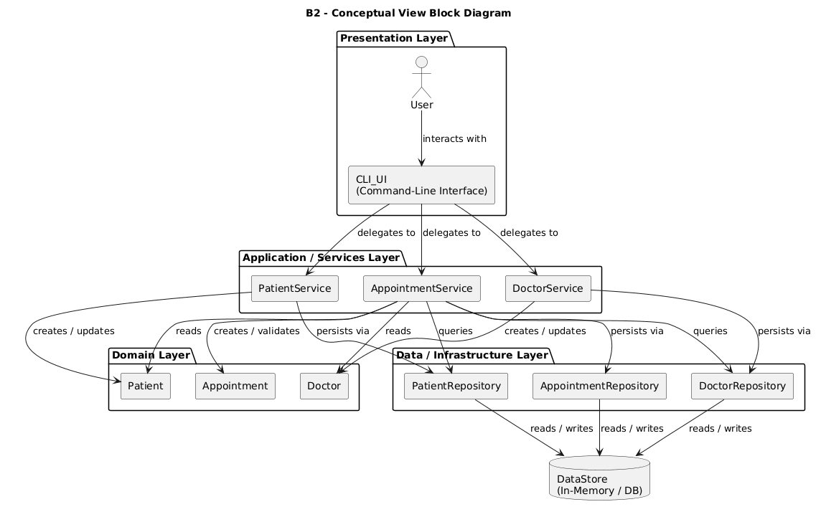
Figure 4.1: Conceptual view — high-level block diagram showing system decomposition.

4.1 Purpose
The Conceptual View presents a high-level structural decomposition of the Hospital Management System. It illustrates the major functional subsystems and their interrelationships, providing stakeholders (developers, project managers, and architects) with an understandable overview of the system's organization without requiring knowledge of low-level implementation details.
This view maps directly to the Layered Architecture pattern, showing how the system is organized into distinct responsibility layers. It also demonstrates the Repository Pattern through the clear separation between the Data Access layer and the underlying storage mechanism.

4.2 System Structure
The system is decomposed into five major subsystems (blocks), each representing an architectural layer with distinct responsibilities:

4.2.1 Presentation Layer (User Interface Subsystem)
Components:
- User: External actor (Receptionist, Admin Staff, or CLI user) who initiates system interactions.
- CLI_UI: Command-Line Interface component responsible for all user interaction. It displays system menus, collects user input, formats output for display, and delegates user requests to the appropriate Application Service.
Responsibilities:
- Capture user commands and input data
- Display system responses and results
- Format data for human readability
- Route user requests to the correct application service
- No business logic — the Presentation layer is purely responsible for interaction
Architecture Compliance:
The Presentation layer strictly follows the Layered Architecture pattern by having no direct access to the Data layer. All requests flow downward through the Application layer, ensuring separation of concerns.

4.2.2 Application / Services Layer (Business Logic Coordination)
Components:
- AppointmentService: Central coordinator for the Book Appointment use case and related workflows. Validates input, orchestrates repository calls, and manages appointment lifecycle.
- PatientService: Manages patient registration, profile updates, and patient lookup operations.
- DoctorService: Handles doctor record management, schedule queries, and availability checking.
Responsibilities:
- Orchestrate use-case workflows (e.g., Book Appointment)
- Coordinate multiple domain objects to accomplish tasks
- Enforce business rules and validation
- Manage transactions across multiple repository operations
- Bridge between Presentation (UI) and Domain (business entities)
Architecture Compliance:
The Application layer depends on the Domain layer (for business entities) and the Data layer (through Repository interfaces). It contains no persistence logic directly—only coordination logic. This aligns with the Repository pattern by accessing data only through repository abstractions.

4.2.3 Domain Layer (Business Entities)
Components:
- Patient: Domain entity representing a hospital patient with core attributes (patientId, name, contact information) and business rules.
- Doctor: Domain entity representing a medical professional with attributes (doctorId, name, specialization, schedule) and availability rules.
- Appointment: Domain entity representing a scheduled appointment with attributes (appointmentId, patientId, doctorId, dateTime, reason, status).
Responsibilities:
- Encapsulate core business concepts and data
- Define business rules and constraints (e.g., appointment status transitions)
- Maintain entity relationships and integrity
- Remain independent of persistence and UI concerns
Architecture Compliance:
The Domain layer is the heart of the system. It has no dependencies on upper layers (Presentation, Application) or infrastructure (Data, Storage). This independence is crucial for:
- Testability: Domain logic can be tested without databases or UI frameworks
- Portability: Domain rules can be reused across different UI technologies
- Maintainability: Business rule changes don't cascade to other layers

4.2.4 Data / Infrastructure Layer (Repository Subsystem)
Components:
- PatientRepository: Repository implementation providing collection-like access to Patient entities. Implements IPatientRepository interface.
- DoctorRepository: Repository implementation managing Doctor entities. Implements IDoctorRepository interface.
- AppointmentRepository: Repository implementation managing Appointment entities. Implements IAppointmentRepository interface.
Responsibilities:
- Abstract all persistence operations behind repository interfaces
- Implement data access operations: findById(), save(), delete(), findAll()
- Translate domain object operations into storage-specific operations
- Isolate the rest of the system from storage technology details
Architecture Compliance:
The Repository pattern is fully realized in this layer. Application services depend only on repository interfaces, not concrete implementations. This enables:
- Storage flexibility: In-memory storage can be replaced with database without changing Application or Domain layers
- Testing: Mock repositories can be used for unit testing
- Separation: Persistence logic doesn't leak into business logic

4.2.5 Storage Layer (Persistence Mechanism)
Component:
- DataStore: The underlying storage mechanism—currently implemented as in-memory Java collections (HashMap, ArrayList). In production, this would be replaced with a relational database, file system, or NoSQL store.
Responsibilities:
- Actually persist and retrieve data
- Manage data storage format (in-memory objects, database rows, file records)
- Handle storage-specific concerns (indexing, caching, transaction logs)
Architecture Compliance:
The Storage layer is isolated behind the Repository layer. No other layer knows whether data is stored in memory, a database, or files. This is the key benefit of the Repository pattern.

4.3 Mapping to Other Architectural Views
The Conceptual View provides the foundation for all other views:
Conceptual Block | Process View (Runtime) | Development View (Components) | Physical View (Deployment)
CLI_UI | Lifeline in Sequence Diagram | CLI_UI component with IUserInterface port | Deployed on Client Machine
AppointmentService | Lifeline receiving calls | AppointmentService component with IAppointmentService interface | Deployed in JVM/Application Server
Patient/Doctor/Appointment | Objects passed in messages | Domain entity classes | Part of Application package
Repositories | Not shown as active lifelines (passive) | PatientRepository, DoctorRepository, AppointmentRepository components | Deployed in JVM with Data Access layer
DataStore | Not shown (implementation detail) | Storage infrastructure component | Database Server or local storage

5. Process View (Dynamic Behavior)

5.1 Selected Scenario / Use Case
Use case name: Book Appointment
Primary actor: Receptionist / Admin Staff (or generic User for CLI)
Preconditions:
- Patient exists (or is registered before booking)
- Doctor exists
- Doctor schedule information is accessible
Main flow summary:
- Actor selects Book Appointment.
- System collects input (patientId, doctorId, requestedDateTime, reason).
- System validates patient and doctor exist.
- System checks doctor availability for the requested slot.
- System creates Appointment (status = Scheduled) and saves it via AppointmentRepository.
- System returns a confirmation (appointmentId + summary).
Alternate flows summary:
- Patient not found → display error → end.
- Doctor unavailable → display conflict and allow retry with another time or cancel.
- Invalid input format → re-prompt for valid input.

5.2 Activity Diagram

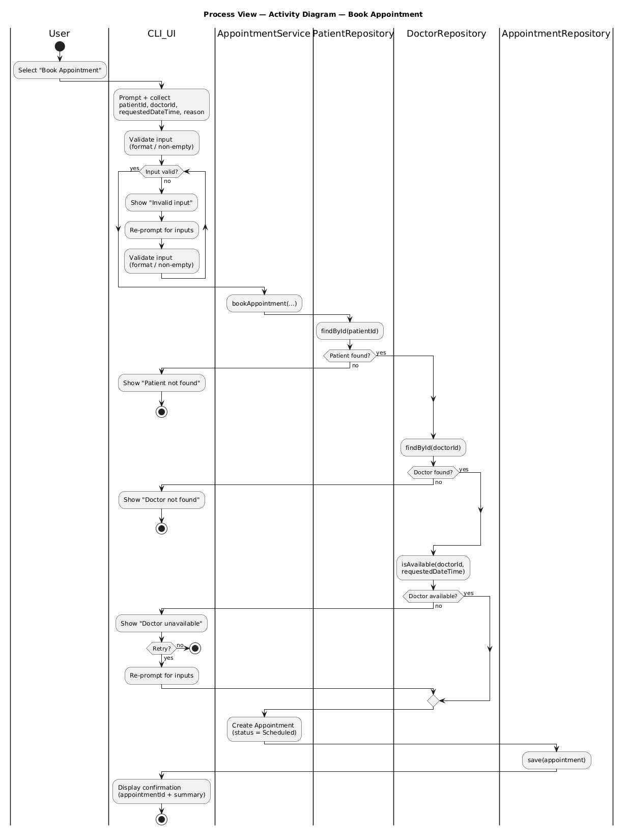
Figure 5.1: Activity diagram for the Book Appointment use case.
The activity diagram illustrates the end-to-end workflow of the Book Appointment use case from a process perspective. It emphasizes the control flow across the system, including validation steps and exception handling, and shows how the workflow moves between the UI, service orchestration, and repository-based data access.
The process begins when the User selects the booking operation in the CLI_UI (Presentation layer). The UI collects the required inputs (patientId, doctorId, requestedDateTime, and reason) and performs basic input validation. A decision point handles invalid input by returning the user to the input step (retry loop).
After validation, the AppointmentService (Application layer) orchestrates the use case. It queries the PatientRepository to confirm the patient exists, then queries the DoctorRepository to confirm the doctor exists, and finally checks doctor availability for the requested time. Decision branches capture the key alternate flows:
- If the patient does not exist, the workflow ends with an error.
- If the doctor does not exist, the workflow ends with an error.
- If the doctor is unavailable, the user can either retry with a different date/time (loop) or cancel.
On success, the service creates an Appointment entity (Domain layer concept) with status Scheduled and persists it through the AppointmentRepository (Data layer). The process ends when the CLI_UI displays a confirmation containing the generated appointmentId and a booking summary.
This diagram maps directly to the layered architecture: CLI_UI represents the Presentation layer, AppointmentService represents the Application layer orchestration, domain entities are created/managed within the service, and repositories represent the Data layer boundary.

5.3 Sequence Diagram

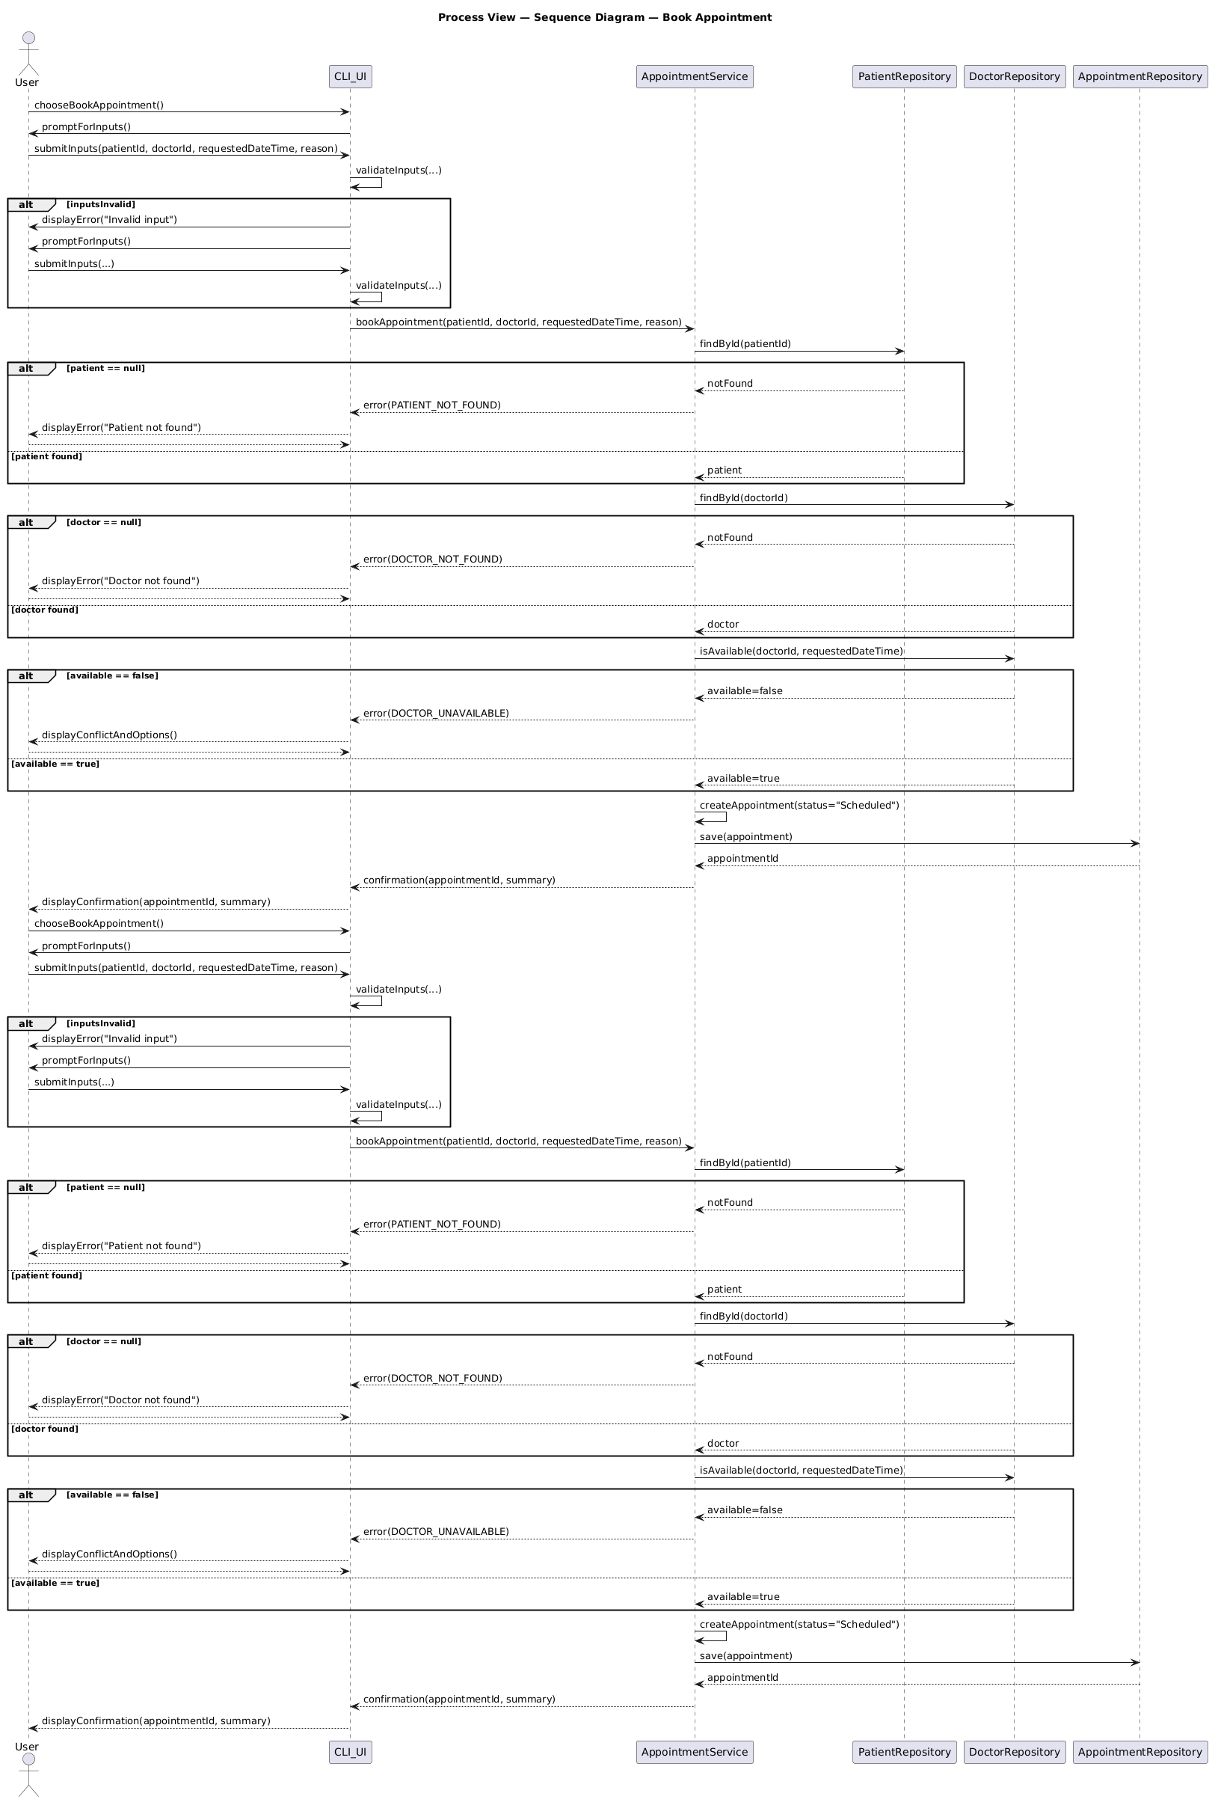
Figure 5.2: Sequence diagram for the Book Appointment use case.
The sequence diagram captures the runtime interactions between components for the Book Appointment scenario, showing the order of method calls and returned results across architectural layers. While the activity diagram focuses on control flow, the sequence diagram focuses on who calls whom, the data passed, and the points where errors can be returned.
The interaction starts when the User triggers booking via CLI_UI. After the user submits the required inputs, the UI calls AppointmentService.bookAppointment(...). The service then performs a set of repository calls to enforce workflow correctness:
- PatientRepository.findById(patientId) to verify the patient exists.
- DoctorRepository.findById(doctorId) to verify the doctor exists.
- DoctorRepository.isAvailable(doctorId, requestedDateTime) to ensure the requested slot is free.
If all checks pass, the service creates an appointment (status Scheduled) and persists it by calling AppointmentRepository.save(appointment), receiving an appointmentId in return. Finally, the service returns a confirmation object/message to CLI_UI, which displays the confirmation to the User.
The diagram also includes alternate (alt) fragments for key failure conditions:
- Invalid input: the UI detects validation issues and requests re-entry before calling the service.
- Patient not found: the service returns an error after the patient repository lookup.
- Doctor unavailable: the service returns a conflict error after the availability check, and the UI offers retry/cancel.
Architecturally, the sequence diagram demonstrates strict layering: the Presentation layer (CLI_UI) calls only the Application layer (AppointmentService), and the service is the only component that interacts with the Data layer (repositories). This reinforces separation of concerns and keeps persistence details out of the UI.

6. Development View (Component Diagram)

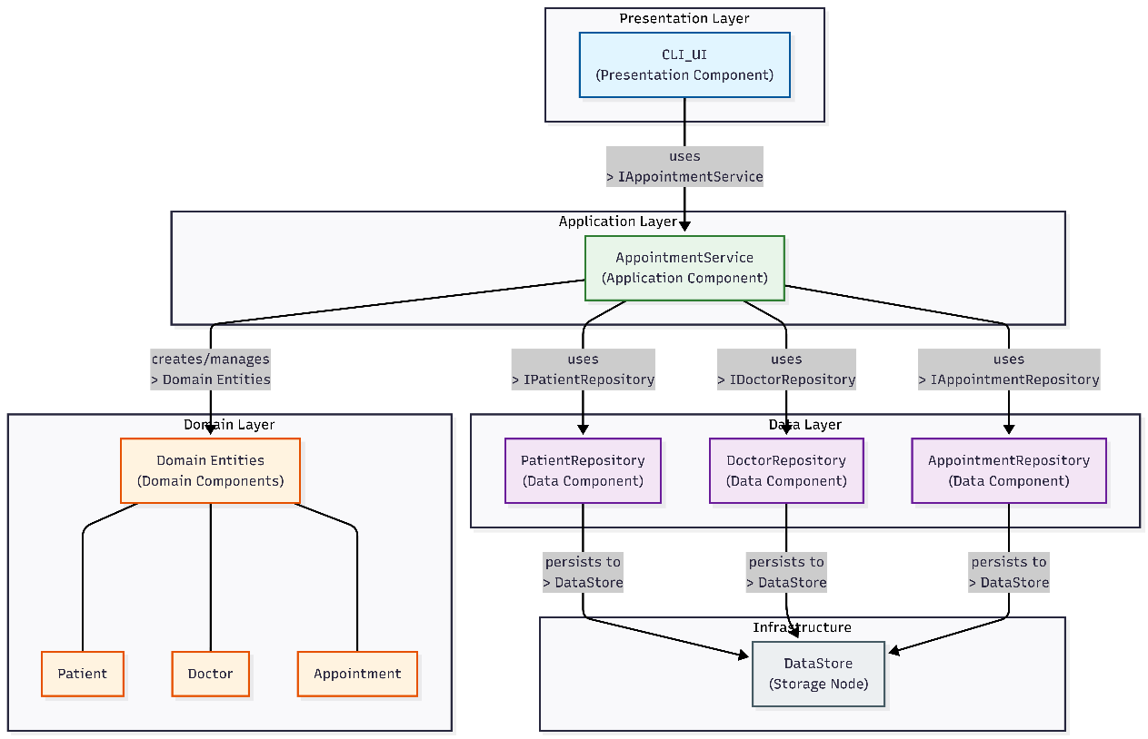
Figure 6.1: UML Component diagram showing the Development View.

6.1 Explanation
The Development View illustrates how the software is organized into implementation units (components) and how they depend on each other. This view maps directly to the Development/Implementation phase and guides developers on code organization.

6.2 Component Overview
Presentation Components:
- CLI_UI — Main user interface component handling input/output
- InputHandler — Parses and validates raw user input
- OutputFormatter — Formats results for display

Application Service Components:
- AppointmentService — Orchestrates appointment workflows
  - Provided interface: IAppointmentService
  - Required interfaces: IPatientRepository, IDoctorRepository, IAppointmentRepository
- PatientService — Manages patient-related operations
- BillingService — Handles billing and payment workflows

Repository Components (Data Access):
- PatientRepository — Implements IPatientRepository
- DoctorRepository — Implements IDoctorRepository
- AppointmentRepository — Implements IAppointmentRepository

Domain Components:
- Patient — Entity class
- Doctor — Entity class
- Appointment — Entity class
- BillingRecord — Entity class

6.3 Interface Definitions
Interface | Provided By | Required By | Operations
IAppointmentService | AppointmentService | CLI_UI | bookAppointment(...), cancelAppointment(...), getAppointment(...)
IPatientRepository | PatientRepository | AppointmentService, PatientService | findById(id), save(patient), findAll()
IDoctorRepository | DoctorRepository | AppointmentService | findById(id), isAvailable(id, datetime), save(doctor)
IAppointmentRepository | AppointmentRepository | AppointmentService | findById(id), save(appointment), findByDoctor(doctorId)

6.4 Dependency Structure
The component diagram enforces the layered architecture:
[CLI_UI] → [IAppointmentService] → [AppointmentService]
↓
┌────────────────────────────┼────────────────────────────┐
↓ ↓ ↓
[IPatientRepository] [IDoctorRepository] [IAppointmentRepository]
↓ ↓ ↓
[PatientRepository] [DoctorRepository] [AppointmentRepository]
Key Design Points:
- Components depend on interfaces, not concrete implementations (dependency inversion)
- All repository dependencies point inward toward the domain
- The AppointmentService is the central coordinator for the Book Appointment use case

7. Physical View (Deployment Diagram)

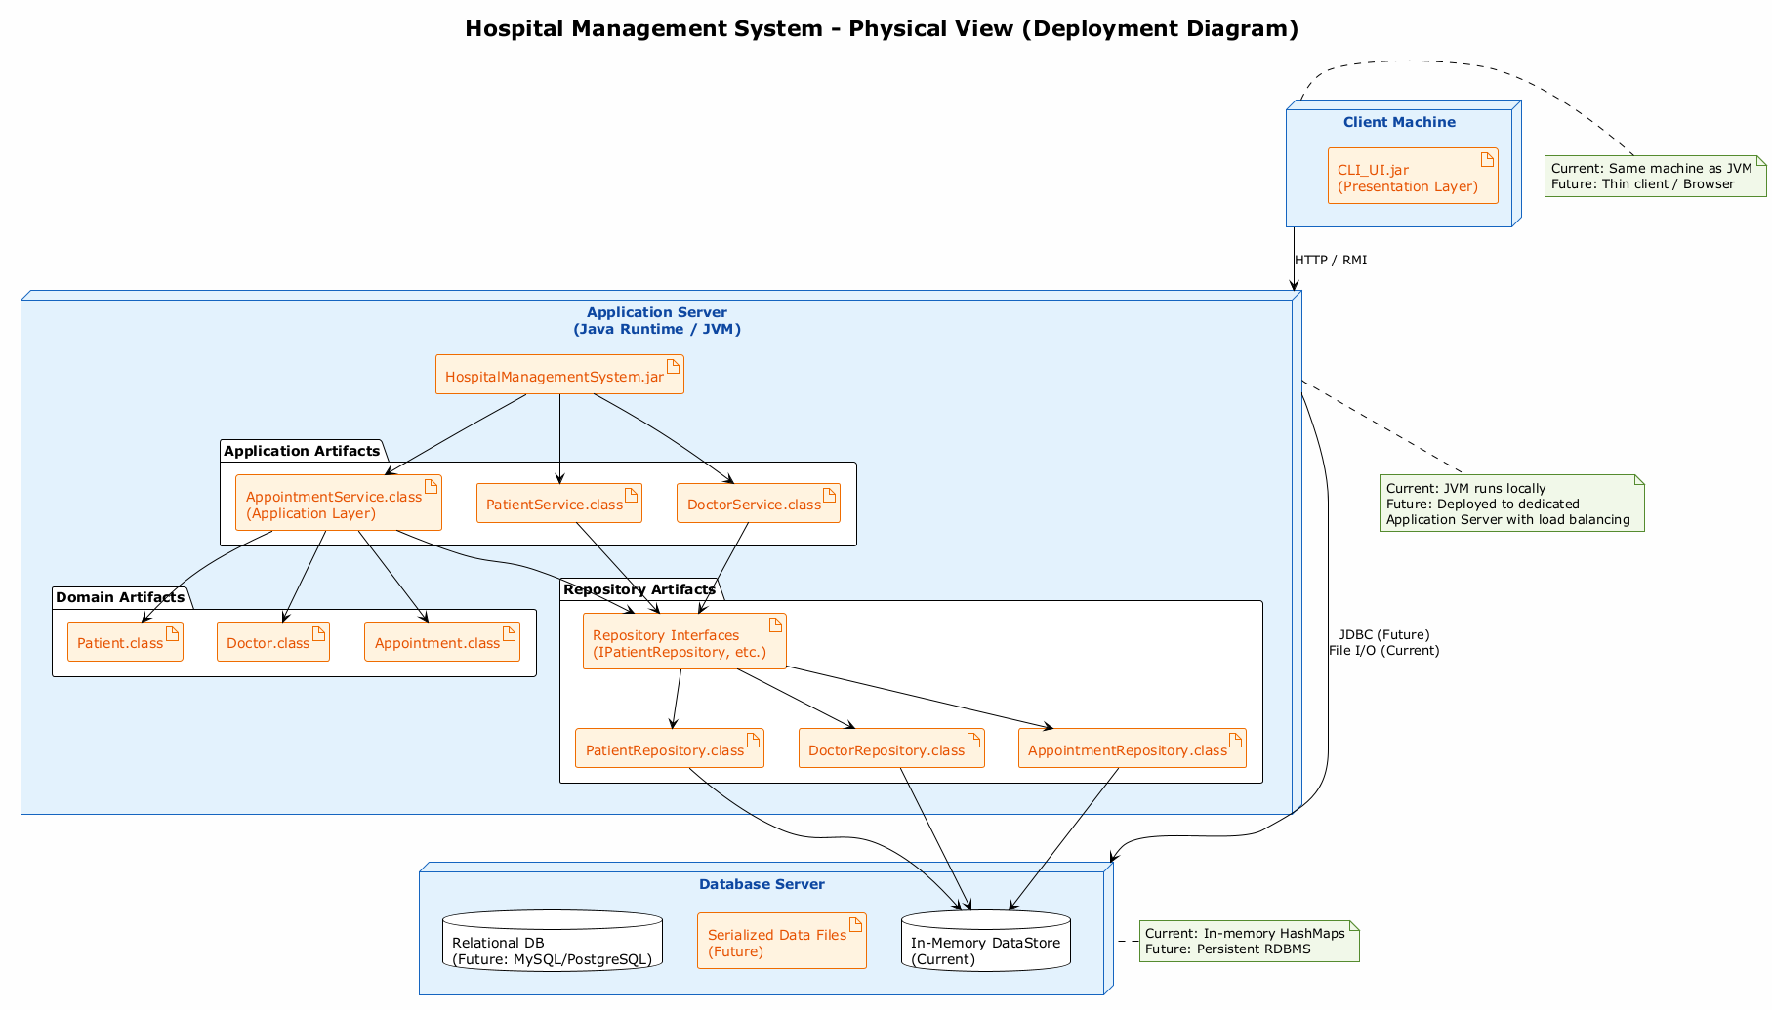
Figure 7.1: UML Deployment diagram showing the Physical View.

7.1 Purpose
The Physical View (Deployment Diagram) maps the logical software components from the Development and Conceptual Views onto physical hardware nodes. It shows how the software artifacts are distributed across machines, the communication paths between nodes, and the runtime environment requirements. This view is essential for system administrators, DevOps engineers, and architects planning infrastructure.
For the Hospital Management System, the current deployment is intentionally simple (single machine) to support academic demonstration, while the architecture is designed to evolve into a distributed client-server deployment without code changes.

7.2 Deployment Nodes

7.2.1 Client Machine
Hardware / Environment:
- Type: Personal computer, workstation, or terminal
- Operating System: Windows, macOS, or Linux
- Runtime: Java Runtime Environment (JRE) 17 or higher
Deployed Artifacts:
Artifact | Layer | Description
CLI_UI.jar | Presentation | Command-line interface executable. Handles all user interaction, menu navigation, input collection, and output display. Depends only on Application Service interfaces.
HospitalManagementSystem.jar | Application bundle | Main JAR containing the application entry point and class loading logic. Orchestrates startup of all subsystems.
Responsibilities:
- Host the user interface component
- Receive user input and display system responses
- Forward requests to the Application Server / JVM
- Current: Runs on the same machine as the Application Server
- Future: Could be a thin client or web browser accessing remote services

7.2.2 Application Server (Java Runtime / JVM)
Hardware / Environment:
- Type: Java Virtual Machine (JVM) instance
- Hosted On: Currently runs on the Client Machine; future deployment on dedicated Application Server
- Runtime: Java Development Kit (JDK) 17+ with required libraries
Deployed Artifacts:
Artifact | Layer | Description
AppointmentService.class | Application | Core service orchestrating the Book Appointment use case and related workflows. Exposes IAppointmentService interface.
PatientService.class | Application | Service managing patient registration, lookup, and profile updates.
DoctorService.class | Application | Service managing doctor records, schedules, and availability queries.
Patient.class | Domain | Domain entity encapsulating patient attributes and business rules.
Doctor.class | Domain | Domain entity encapsulating doctor attributes and availability logic.
Appointment.class | Domain | Domain entity representing scheduled appointments with status management.
PatientRepository.class | Data | Repository implementing IPatientRepository for patient persistence.
DoctorRepository.class | Data | Repository implementing IDoctorRepository for doctor persistence and availability checks.
AppointmentRepository.class | Data | Repository implementing IAppointmentRepository for appointment persistence.
Repository Interfaces | Data | Interface definitions (IPatientRepository, IDoctorRepository, IAppointmentRepository) that decouple Application Services from concrete repository implementations.
Responsibilities:
- Execute all business logic and workflow orchestration
- Manage domain object lifecycles
- Coordinate data access through repository abstractions
- Current: Runs locally within the same JVM as the client
- Future: Deployed as a standalone service with load balancing and clustering

7.2.3 Database Server
Hardware / Environment:
- Type: Storage node — currently in-memory; future: dedicated database server
- Hosted On: Currently same machine as Application Server; future: separate database host
Deployed Artifacts:
Artifact | Technology | Description
In-Memory DataStore | Java HashMap/ArrayList | Current storage: in-memory collections providing O(1) lookups. Volatile — data is lost on shutdown.
Serialized Data Files | Java Serialization / JSON | Future enhancement: persist in-memory data to files between sessions for basic durability.
Relational Database | MySQL / PostgreSQL | Production target: persistent relational database with ACID guarantees, indexing, and concurrent access support.
Responsibilities:
- Persist and retrieve all system data
- Ensure data integrity and consistency
- Current: In-memory collections for demonstration simplicity
- Future: Full RDBMS with backup, replication, and transaction management

7.3 Communication Paths
Connection | Protocol | Bandwidth | Purpose
Client Machine → Application Server | Local method invocation (current); HTTP / RMI / REST (future) | N/A (in-process) | UI delegates requests to Application Services
Application Server → Database Server | Direct field access (current); JDBC (future) | N/A (in-process) | Repositories persist and retrieve data

Current Communication (Single Machine):
All components run within the same JVM process. Communication between CLI_UI and AppointmentService is direct method invocation. Repositories access in-memory collections via direct field references. No network overhead.

Future Communication (Distributed):
- Client Machine connects to Application Server via HTTP/REST or RMI
- Application Server connects to Database Server via JDBC with connection pooling
- Network latency becomes a consideration; the Repository pattern's batch operations and caching strategies address this

7.4 Architecture Support for Deployment
The chosen architecture directly supports flexible deployment through two key design decisions:

7.5 Deployment Evolution Roadmap

Phase 1: Current — Single-Node Deployment (Demonstration)
┌─────────────────────────────────────┐
│ Client Workstation │
│ ┌──────────────┐ ┌───────────────┐ │
│ │ CLI_UI.jar │ │ JVM with │ │
│ │ │ │ Application │ │
│ │ │ │ Services │ │
│ │ │ │ + Domain │ │
│ │ │ │ + Repos │ │
│ └──────────────┘ └───────────────┘ │
│ │ │ │
│ └────┬────┘ │
│ ↓ │
│ ┌──────────────┐ │
│ │ In-Memory DB │ │
│ └──────────────┘ │
└─────────────────────────────────────┘
Characteristics:
- Single machine, single JVM
- In-memory storage (data lost on shutdown)
- Direct method calls between all components
- Suitable for: development, testing, academic demonstration

Phase 2: Enhanced — File Persistence (Short-Term)
Same as Phase 1, but repositories serialize data to JSON or binary files on shutdown and deserialize on startup. Provides basic durability without adding external dependencies.

Phase 3: Production — Client-Server with Database (Future)
┌─────────────────┐ HTTP/REST ┌──────────────────────────┐ JDBC ┌─────────────────┐
│ Client Machine │ ◄──────────────► │ Application Server │ ◄─────────► │ Database Server│
│ │ │ (JVM) │ │ (MySQL/PgSQL) │
│ ┌───────────┐ │ │ ┌──────────────────┐ │ │ │
│ │CLI_UI.jar │ │ │ │ ApplicationServices│ │ │ │
│ │ │ │ │ │ DomainEntities │ │ │ │
│ │ │ │ │ │ RepositoryInterfaces│ │ │ │
│ └───────────┘ │ │ └──────────────────┘ │ │ │
│ │ │ ↓ │ │ │
│ Thin Client │ │ ┌──────────────────┐ │ │ │
│ (or Browser) │ │ │ RepositoryImpl │───┘ │ │
│ │ │ └──────────────────┘ │ │
└─────────────────┘ └──────────────────────────┘ └─────────────────┘
Characteristics:
- Three-tier architecture with physical separation
- Application server handles business logic and can be load-balanced
- Database server provides ACID transactions, indexing, and concurrent access
- Client machines run thin UI only
- Suitable for: production hospital deployment, multi-user access, data durability

7.6 Mapping to Development View
Development View Component | Physical View Artifact | Deployment Node
CLI_UI | CLI_UI.jar | Client Machine
AppointmentService | AppointmentService.class (in HospitalManagementSystem.jar) | Application Server (JVM)
Patient, Doctor, Appointment | Patient.class, Doctor.class, Appointment.class | Application Server (JVM)
PatientRepository, DoctorRepository, AppointmentRepository | PatientRepository.class, DoctorRepository.class, AppointmentRepository.class | Application Server (JVM)
DataStore (logical) | In-Memory DataStore (current) / Relational Database (future) | Database Server

Decision: In-memory storage with Repository abstraction
- Rationale: Demonstrates the Repository pattern's core benefit — storage independence. The same Application and Domain code will work with a database later.
- Trade-off: Data volatility. Mitigated by file serialization (Phase 2) and database migration (Phase 3).

Decision: JVM as the application runtime
- Rationale: Java's platform independence ensures the system runs on any OS. The JVM's memory management and threading model support future scalability.
- Trade-off: JVM startup overhead and memory consumption. Acceptable for a hospital management system where long-running processes are typical.

8. Bonus — Reference Architecture Mapping

8.1 Mapping to 4+1 Architectural View Model
Our View | 4+1 Model Equivalent | Purpose
Conceptual View (Block Diagram) | Logical View | Shows functional decomposition for stakeholders
Process View (Activity + Sequence) | Process View | Shows runtime behavior and interactions
Development View (Component) | Development View | Shows software organization for developers
Physical View (Deployment) | Physical View | Shows deployment on hardware
Scenarios (Book Appointment) | Use Case View | Drives the other four views

8.2 Mapping to IEEE 1471 / ISO 42010
Architecture Concept | Our Implementation
Stakeholders | Patients, Doctors, Admin Staff, Developers
Concerns | Functionality, maintainability, scalability
Viewpoints | Logical, Process, Development, Physical
Views | Sections 4–7 of this report
Models | UML diagrams (.mdj files)

8.3 Architecture Trade-offs
Decision | Rationale | Trade-off
In-memory repositories | Simplicity for academic demonstration | Lost durability (data lost on shutdown)
CLI interface | Focus on architecture, not UI complexity | Limited usability compared to GUI
Single-node deployment | Simplicity of demonstration | Limits scalability (addressed in Physical View evolution)

8.4 Transaction Processing System Reference Architecture
The Hospital Management System follows the Transaction Processing System (TPS) reference architecture pattern. This architecture is designed for applications that process discrete user requests as transactions, maintaining data integrity and providing immediate feedback—exactly matching our appointment booking workflow.
Relevance to Our System:
- User requests (book appointment, register patient) are discrete transactions
- Each transaction must maintain data consistency (e.g., doctor availability checks before booking)
- System provides immediate confirmation/feedback to users
- Requires persistent storage with ACID properties (evolution path in our Physical View)
Architecture Mapping:
The diagram below shows how our HMS components map to the standard Transaction Processing System layers:
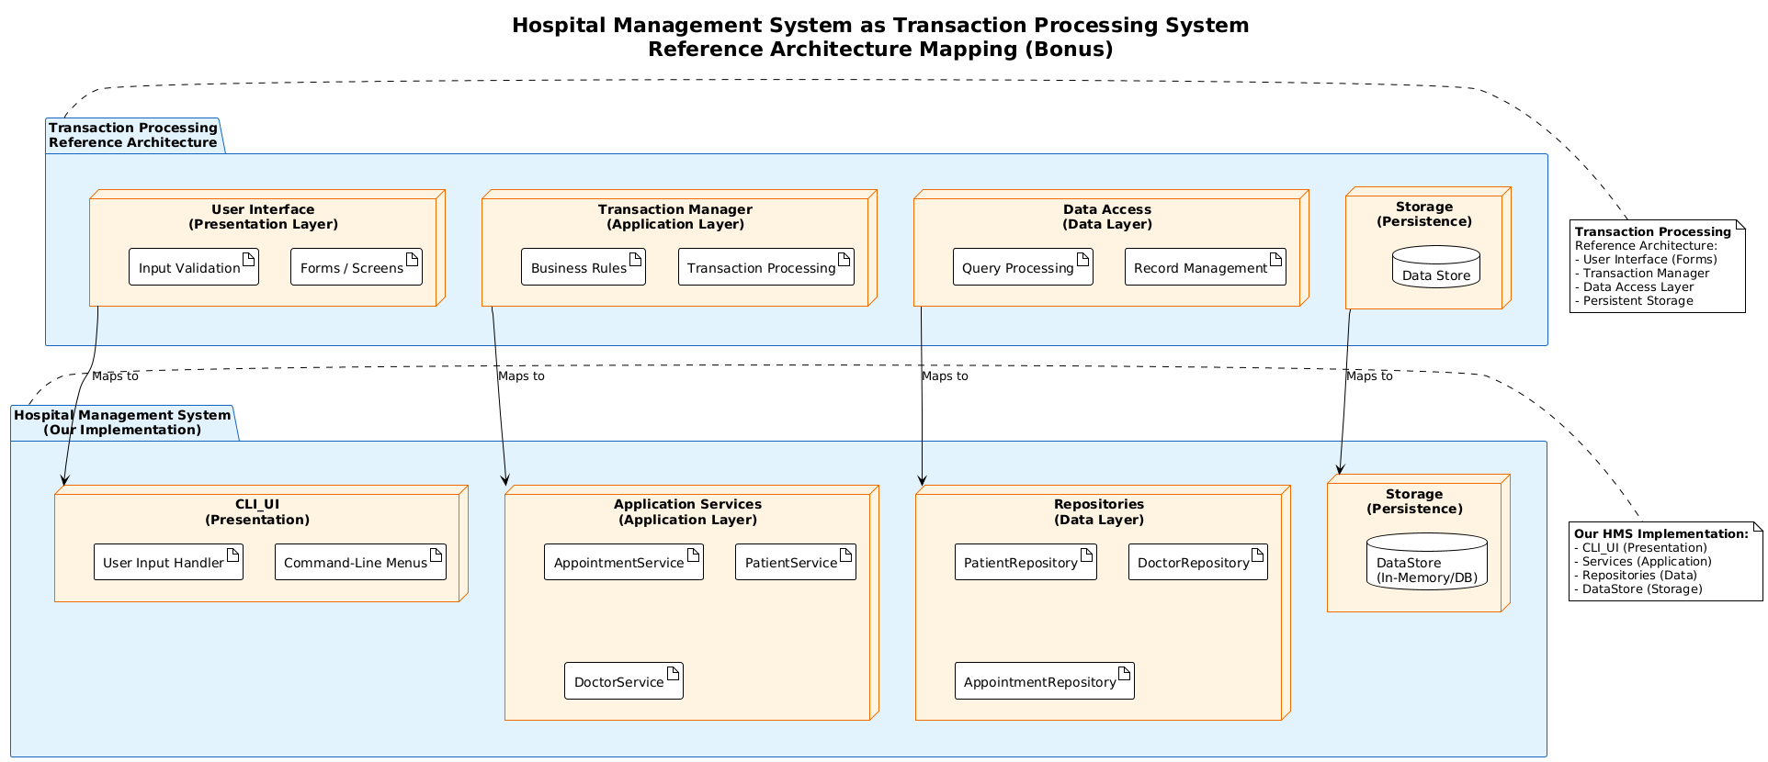
Mapping Details:
TPS Layer | HMS Component | Purpose
User Interface | CLI_UI | Collects user input, displays menus and results
Transaction Manager | AppointmentService, PatientService, DoctorService | Orchestrates workflows, enforces business rules, manages transaction boundaries
Data Access | PatientRepository, DoctorRepository, AppointmentRepository | Abstracts persistence, provides collection-like data access
Storage | DataStore (In-Memory/Database) | Physical data persistence with integrity guarantees
Key Architectural Alignment:
- Our Repository Pattern maps directly to TPS Data Access layer
- Our Layered Architecture separates concerns matching TPS structure
- The Book Appointment use case exemplifies a complete transaction: input → validation → processing → storage → confirmation
This reference architecture validates our design choices and provides a proven foundation for evolving the system toward production-grade transaction processing with database persistence.

9. Conclusion
This report presented the software architecture for the Hospital Management System using the 4+1 Architectural View Model. The architecture is built on two fundamental patterns:
- Layered Architecture — Provides separation of concerns across Presentation, Application, Domain, and Data layers.
- Repository Pattern — Abstracts data access, enabling flexibility in persistence mechanisms and supporting testability.
The four architectural views demonstrate:
- Conceptual View: High-level system decomposition into four major subsystems
- Process View: Dynamic behavior through Activity and Sequence diagrams for the Book Appointment use case
- Development View: Component structure with interfaces and dependencies
- Physical View: Deployment on hardware nodes with evolution path for scalability
The Non-Functional Requirements analysis shows how the architecture supports performance, security, availability, maintainability, and scalability. The Repository pattern and Layered Architecture together provide a solid foundation that can evolve from the current single-user CLI application to a multi-user client-server deployment with database persistence.
All diagrams were created using StarUML and follow standard UML notation. The architecture is consistent across all views, with the Book Appointment scenario serving as the driving use case that validates the design.

Appendix A — Assumptions & Glossary

A.1 System Assumptions

A.1.1 Deployment Environment
- Assumption: The system is deployed as a single-user CLI Java application running locally on a single machine.
- Rationale: This simplifies the demonstration and grading of the architectural patterns without the complexity of distributed deployment.
- Impact: The Physical View shows single-node deployment, but the architecture supports evolution to client-server if needed.

A.1.2 Authentication & Authorization
- Assumption: No login, role-based access control, or user authentication is implemented in this version.
- Rationale: Access control is out of scope for this deliverable; the architecture places validation in the Application Service layer where authentication would be added in future iterations.
- Impact: The Sequence Diagram shows direct user interaction without authentication gates.

A.1.3 Concurrency
- Assumption: The system runs sequentially with no concurrent user access or multi-threading.
- Rationale: Simplifies the architecture demonstration; the Repository pattern supports adding concurrency later.
- Impact: No synchronization mechanisms are shown in the Component Diagram.

A.1.4 Data Persistence
- Assumption: Data storage is in-memory using Java collections (HashMap, ArrayList).
- Rationale: Demonstrates the Repository pattern's flexibility—storage mechanism can be replaced without changing business logic.
- Impact: Data is volatile; all data is lost when the application stops. The NFR section addresses this risk and migration path.

A.1.5 Scope Limitations
- Assumption: Only the "Book Appointment" scenario is modeled in detail for Process View diagrams.
- Rationale: This use case exercises all architectural layers (Presentation, Application, Domain, Data) and demonstrates the Repository pattern effectively.
- Impact: Other use cases (cancel appointment, view schedule, billing) follow the same architectural pattern but are not diagrammed.

A.1.6 Architecture Focus
- Assumption: The deliverable focuses on architectural structure and patterns, not low-level implementation details.
- Rationale: Deliverable #4 is about software architecture, not code implementation.
- Impact: Diagrams emphasize component relationships and layer boundaries rather than method implementations.

